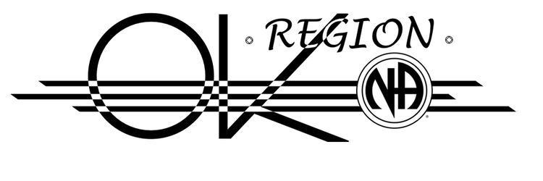We meet on August 11th, 2024 at 107 W. Moses, Cushing, OK. Minutes are posted at [www.okna.org](http://www.okna.org)

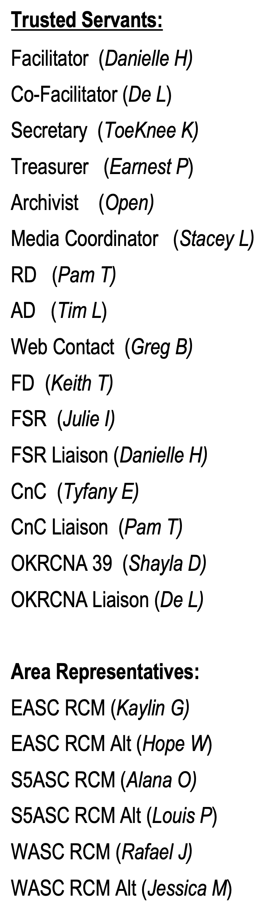

*OKNA, Inc. Board:* OKNA, Inc. is the newly formed 501(3)c organization for OKRSC. It meets quarterly and takes all direction from OKRSC. ToeKnee K was added as new board member and elected as OKNA, Inc. Secretary.

*NA World Service Stuff*  **-** There is an open fellowship survey on what might be included in future step working literature. To provide input, go to www.na.org/survey.

*World Convention* - 38 WCNA 38 in Washington DC, 29 August–1 September 2024

World Unity Day Speaker, Sunday, September 1. Free, online audio stream of the closing speaker for WCNA will be at 9:30 am Central Time.

*NAWS Annual Financial Report*– NAWS finances from July 1, 2022, through June 30, 2023, can now be found at www.na.org/ar

*NAWS Issue Discussion Topics (IDTS)—Workshop material*  **-** the Four Issue Discussion Topics that the Conference Participants prioritized for this cycle is available to any member at www.na.org/idt. The topics are Disruptive and Predatory Behavior, Gender-Neutral and Inclusive Language in NA, and DRT/MAT as It Relates to NA Reimagining and Revitalizing Service Committees. The Delegate Team can assist with presentations, but the material is laid out so interested members can present.

*Significant Dates*

• World Unity Day - September 1, 2024

• Sponsorship Day - December 1, 2024

*PSZF In-Person Meeting in OK Region*

The OK Region will host the next [Plains State Zonal Forum](https://pszfna.org) (PSZF) in-person meeting in Oklahoma City on November 1-3, 2024 at the Crown Heights United Methodist Church, 1021 NW 37 in OKC, where No Grass Group meets. This event is free and open to all to attend.

*Fellowship Development: A* significant amount of work has been done to develop a relationship with Oklahoma Department of Corrections (OKDOC). Currently we are providing literature/meeting list racks at Probation & Parole offices around the state. Also, we are currently bringing a PR table into prison re-entry fairs throughout Oklahoma.

**Next FD Meeting:** Sept 8th, 2024 9:00 AM; Join Zoom Meeting - Meeting ID: 865 6026 7275; Passcode: 1953

<https://us02web.zoom.us/j/86560267275?pwd=V3R5ajVKU0VYL21ackZGZUlxdUpmQT09>

*Clean & Crazy Campout (CnC):* This past CnC was a success in sharing recovery and made a little over $3000. We elected a Chair for 2025 (Tyfany E.). Look for the committee to start meeting towards the end of 2024.

*OKRCNA 39:* Planning for the next OKRCNA in OKC is in full swing. Working to finalize dates and location. There are open opportunities to help serve. If you would like to participate with this committee, it meets on the 3rd Sunday at 1 PM at the Cushing Connection (109 W. Moses) meeting location.

*Fall Spiritual Retreat (FSR):* Planning for the 38th FSR is in full swing. Join us at Camp Waluhili (67246 S. 320 Rd., Chouteau, OK 74337) on Nov 8-10. Fun-raiser scheduled for Aug 17 at 1529 W. 49th, Tulsa, OK. If you would like to participate with this committee, it meets via Zoom on the 3rd Sunday at 2 PM.

*General Service Assembly (GSA):* Next GSA will be Feb 7-9, 2025. OKRSC will meet on that Sunday.

*Revitalizing & Reimagining Regional Service:* This workgroup was established from our last regional inventory. It is working on how we make regional service more appealing to addicts in the OK Region.

*Making Rural Meetings More Available:* This workgroup was established from our last regional inventory. It is working on how we make recovery available in the rural areas of our region. Currently working on providing a virtual meeting made up of recovering addicts in the OK Region.

*Activities Handbook:* A workgroup has been formed to update our Activities Handbook. This handbook guides our subcommittee in putting on regional events First meeting is at 6 pm on 8/21/24. Join Zoom Meeting <https://us02web.zoom.us/j/88549931317>  Meeting ID: 885 4993 1317

*Recent Elections:* Stacey L - Media Coordinator; Tyfany E. – Clean & Crazy 2025 Chair; Pam T. – Clean & Crazy Liaison

*Positions to Fill at next RSC:* Archivist, OKDOC Coordinator

*Upgrade Virtual Equipment:* RSC discussed upgrading equipment for the virtual RSC experience.

**Proposal: That RSC spend up to $1500 on equipment to improve virtual experience.**

**Intent: The OK Region offers the ability to participate fully virtually. This option has made it possible for us to fill positions that were difficult to fill by members who are unable to travel for the meeting. This includes several standing committee chairs. However. The virtual experience has been less than effective. Members attending online cannot hear the reports or discussion. For this reason, we are asking for an upgraded camera and microphones that can be tethered to get more reach.**

*Additional Funds for PSZF Hosting:* PSZF provides $600 to host the event. Delegate team requested additional $300 from OKRSC to provide additional meals for the event. Agreed.

*OKRSC Facebook page:* OKRSC is working on establishing a facebook page. It will be a ‘public’ page (visible to all), but content will be closely managed. More to come….

**Next Region:** October 13th, 2024 in Southern 5th Area, 706 Ridley Rd, Duncan, OK

Fellowship Development at ***9 to 10:30 AM***; Regular Business at ***11 AM***

Join Zoom Meeting:<https://us02web.zoom.us/j/84849722846?pwd=Rjh6TWxUT2xjUXNXd3BvUzZ6ZDBvdz09>

Meeting ID: 848 4972 2846; Passcode: 1953